HSEV Work List Module
A Quick Guide

1. Work List Report

The work list report shows all active (complete/pending) work list items. By default, it shows items created from January of the current year up to present date. Date range can be changed along with other parameters as per the choice of the viewer.

  - Accessing the Report

To access the report:

- Go to https://apps.epshipping.com.sg/. From the main menu, click HSEV.
- Under Work List section, click Work List Report

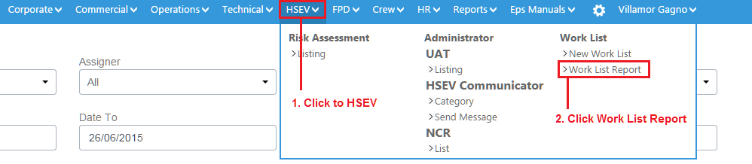

  - Navigating the Report

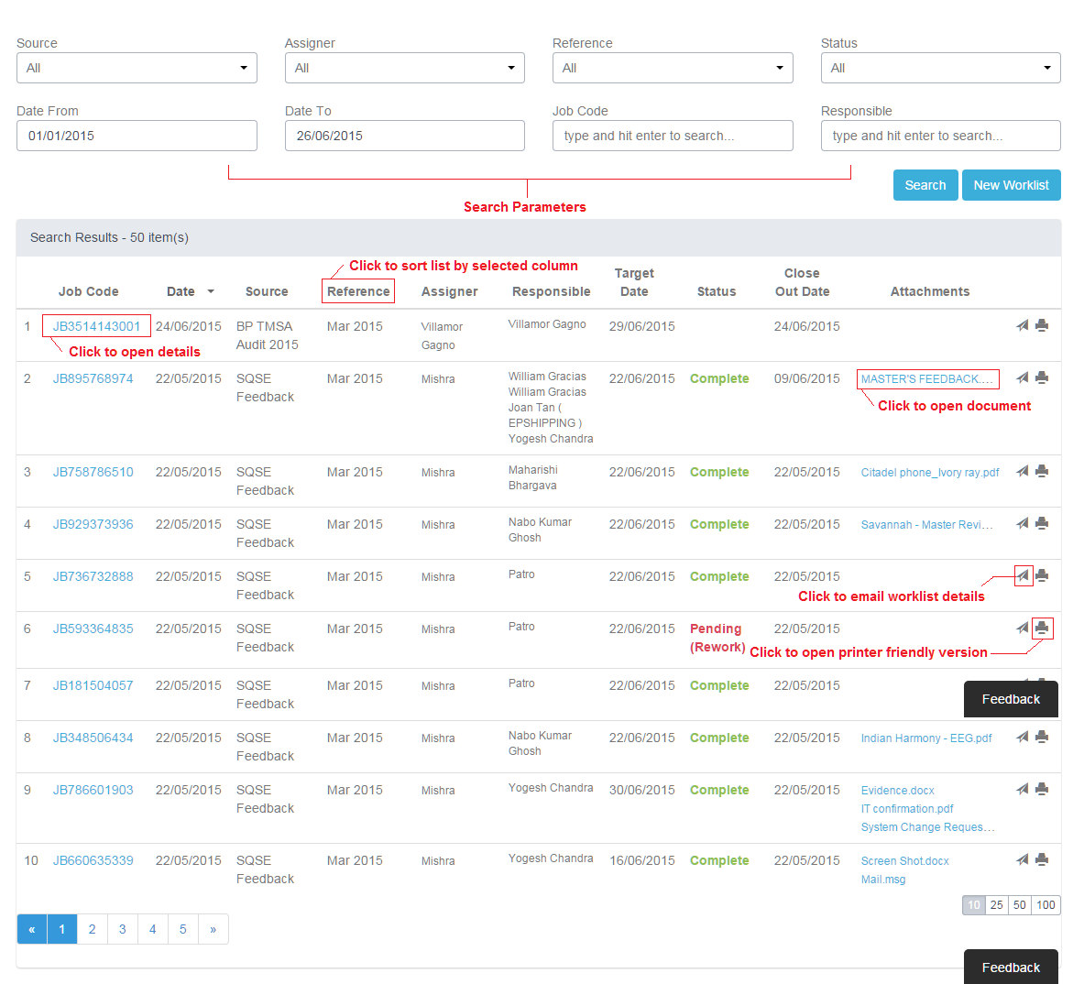
To navigate:

- Select the search parameters to use and click Search to view report.
- To see a detailed view of the worklist, simply click the job code link under the Job Code column of the report.
- You can sort the report by clicking the column titles. The up/down arrow indicates which column the report is currently sorted in. Up arrow mean sorted in descending order while down means ascending order.
- All the attached documents can be accessed directly by clicking the filename under the Attachments column. Note that long file names are trimmed. To view the full filename simply hover the mouse pointer over the link and wait for the hover caption to appear.
- Clicking the paper plane icon will open a new outlook message window with subject titled ‘Work List Job Code: JBxxxxxxxxxx’.
- Clicking the printer icon will open a printer friendly version of the work list details.

2. Work List Details

The work list details page shows all the information related to a particular worklist item.
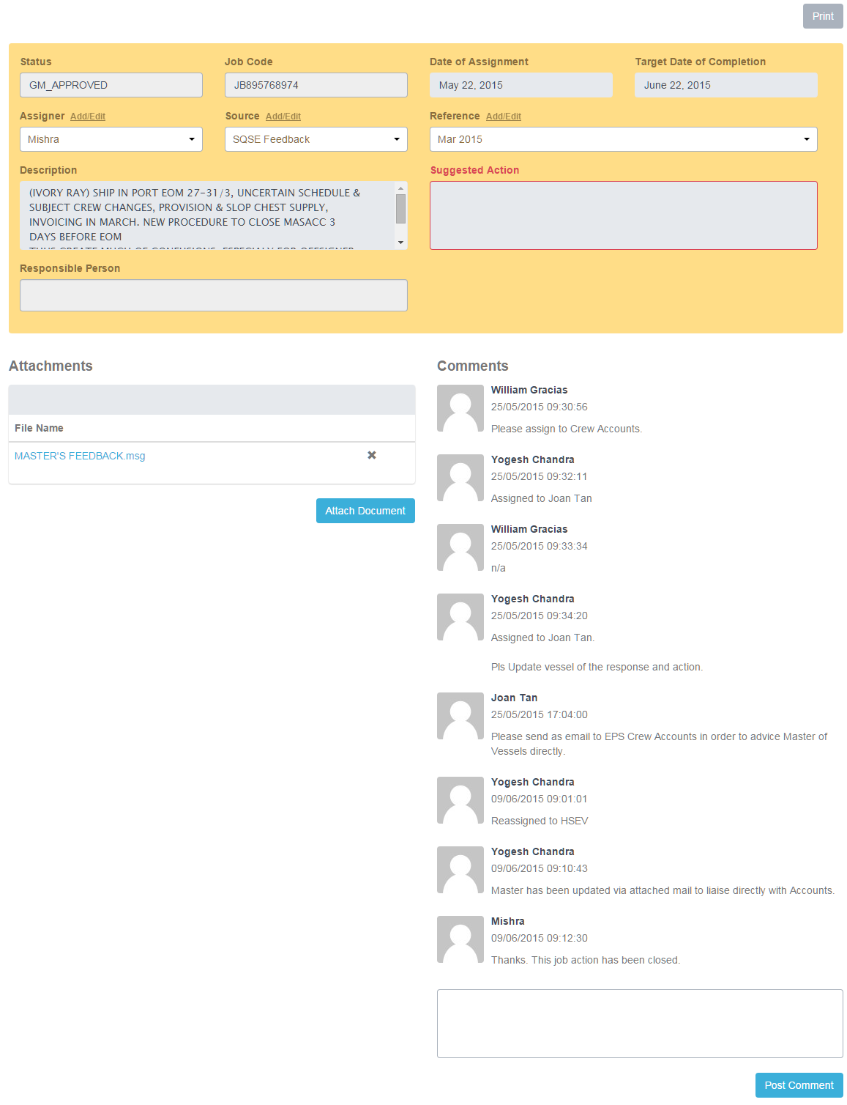
2.1 Processing the Work List Item

Based on the user’s role, relevant buttons will appear at the topmost right side of the page.

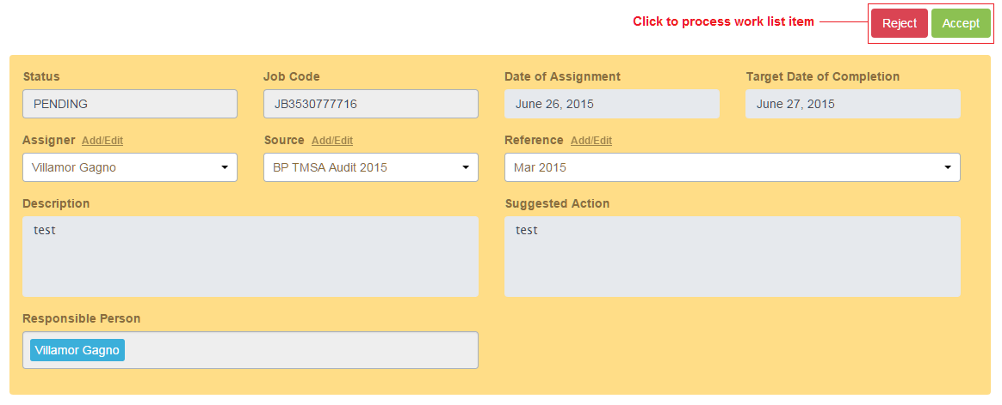

2.2 Uploading Documents

You can attach relevant documents in the Attachment section of the page. Just click the Attach Document button to open the file explorer. Successfully uploaded files will appear in the attachment list.

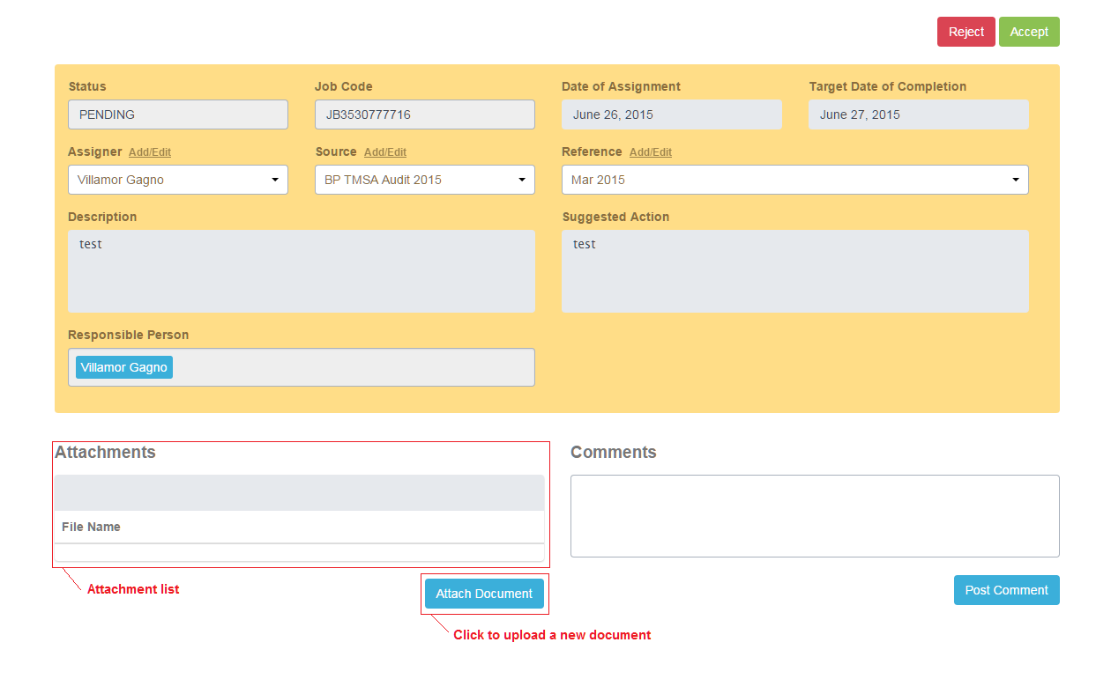

2.3 Posting comments

The comments section will by default show the action remarks made by a user (e.g. approval/rejection remarks). A user can manually add a comment as well by typing in the comments in the comment box then clicking the Post Comment button.

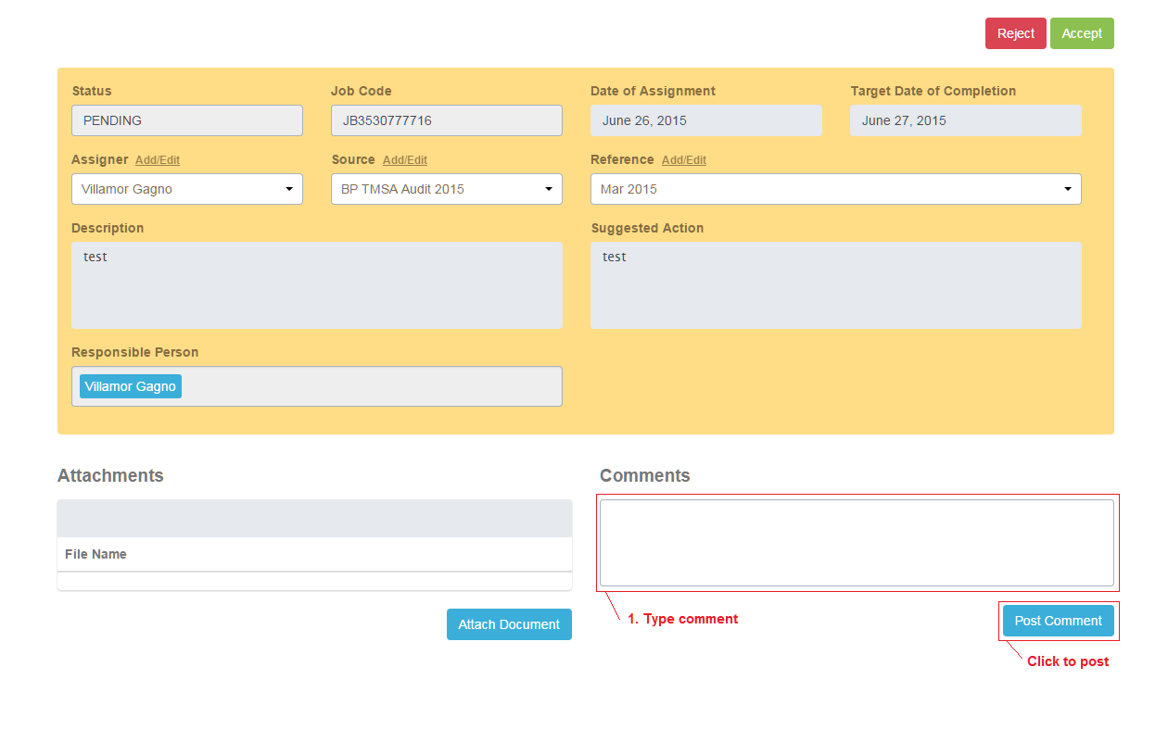

3. New Work List Item

3.1 Creating a New Item

To create a new item:

- Go to https://apps.epshipping.com.sg/.
- From the main menu, click HSEV.
- Under Work List section, click New Work List.

3.2 Adding a Responsible Person

The Responsible Person field allows you to key in multiple users. To add:

- Type in the name of the employee you want to add.

- A list of suggested employee names will appear just below the textbox.

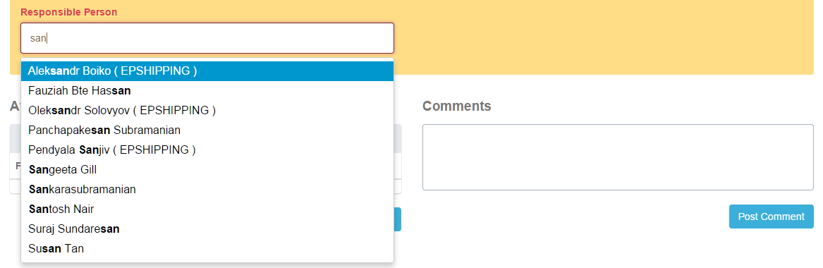

- Select the employee you want to add by using the UP/DOWN scroll keys then pressing ENTER. Alternatively you can just left-click the employee name using the mouse.

- You can remove the employee from the list by either using the BACKSPACE key or clicking the ‘x’ button beside the employee’s name.

